SOCKS Proxy
# Source: Chatgpt (GPT-5-Mini) at [1/16/2026]
A SOCKS Proxy is a general-purpose proxy server that works at a lower level than HTTP/HTTPS proxies. It forwards any type of network traffic (not just web traffic) between a client and a server.

🧭 What Does SOCKS Stand For?
# Source: Chatgpt (GPT-5-Mini) at [1/16/2026]
SOCKS = Socket Secure
It's a protocol that routes packets between a client and server through a proxy.

🔄 How SOCKS Proxy Works:
# Source: Chatgpt (GPT-5-Mini) at [1/16/2026]
[Client App] ──► [SOCKS Proxy] ──► [Target Server]

- Your application (like a browser, torrent client, or game) connects to the SOCKS proxy.
- The proxy relays the connection to the destination server.
- The response returns the same way.
The SOCKS proxy doesn’t inspect or interpret the data — it just forwards it.

🧰 Use Cases:
# Source: Chatgpt (GPT-5-Mini) at [1/16/2026]
- Bypassing geo-blocks or firewalls
- Anonymizing traffic
- Handling non-HTTP traffic like:
  - Email (SMTP, IMAP)
  - FTP
  - P2P applications (BitTorrent)
  - Online games
  - SSH tunneling

🔄 SOCKS vs HTTP Proxy:
# Source: Chatgpt (GPT-5-Mini) at [1/16/2026]
Feature | SOCKS Proxy | HTTP Proxy
Protocol | SOCKS (TCP/UDP support) | HTTP/HTTPS only
Data handling | Doesn’t interpret content | Understands and can modify HTTP data
Use cases | Browsers, P2P, FTP, games | Web browsing and HTTP traffic
Performance | Faster, lightweight | Can be slower due to parsing

🧪 SOCKS4 vs SOCKS5:
# Source: Chatgpt (GPT-5-Mini) at [1/16/2026]
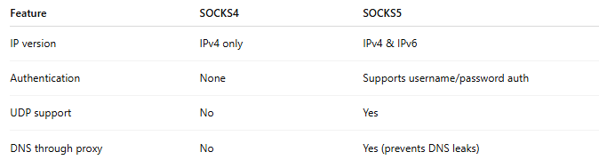

Feature | SOCKS4 | SOCKS5
IP version | IPv4 only | IPv4 & IPv6
Authentication | None | Supports username/password auth
UDP support | No | Yes
DNS through proxy | No | Yes (prevents DNS leaks)
🟢 SOCKS5 is more advanced and preferred today.

🔐 Does SOCKS encrypt your data?
# Source: Chatgpt (GPT-5-Mini) at [1/16/2026]
No. SOCKS proxies do not encrypt your traffic. They just forward it.
To add encryption, you can combine it with tools like SSH tunnels or a VPN.

